A

Report on

# “Content Management System”

Submitted by

#### Mr. Tushar Munjaji More (1930331245051)

Certification Offered by

#### SiliconMount Tech Services

Under the Guidance of

**Asst. Prof. Harsha Gaikwad**

**In the partial fulfilment of B. Tech. in Computer Engineering course of Dr. Babasaheb Ambedkar Technological university, Lonere (Dist. Raigad) in the academic year 2022- 2023**



**Department of Computer Engineering**

#### Dr. Babasaheb Ambedkar Technological University, Lonere.

**Lonere-40210**

**2022 – 2023**

**Dr.Babasaheb Ambedkar Technological University “Vidyavihar”, Lonere–402103 Tal.Mangaon, Dist.Raigad,(Maharashtra State) INDIA**

# CERTIFICATE

This is to certify that the “**Internship Report**” is submitted by **Mr. Tushar Munjaji More(1930331245051)** is record of bonafide work carried by under my guidance in the partial fulfillment the requirement for the award of degree of B.Tech in Computer Engineering coursed of Dr. Babasaheb Ambedkar Technological University, Lonere during the academic year 2022-2023.

|  |  |
| --- | --- |
| **Asst. Prof. Harsha Gaikwad Internal Guide**  Department of Computer  Engineering | **Prof. Dr. L.D. Netak Head of Department** Department Computer  Engineering |

Examiners:

1. Name Sign
2. Name Sign

Date: 26/06/2023

Place: Dr. Babasaheb Ambedkar Technological University, Lonere, Dist. Raigad

# INTERNSHIP LETTER

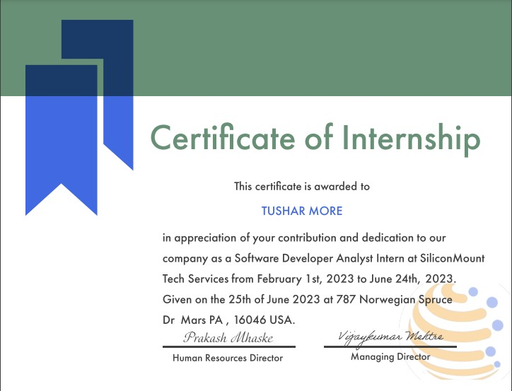

**ACKNOWLEDGEMENT**

It gives me immense pleasure to present my report on “**Internship**”. The guidance of all teaching staff of the department made the study possible. They have been a constant source of encouragement throughout the completion of this project. We would like to express our gratitude thanks to **Dr. L. D. Netak** sir who motivated us and to **Asst. Prof. Harsha Gaikwad** madam who guided properly for this training. We would also like to express our sincere thanks to the Computer Department for giving us an opportunity to explore new trainings.

Mr. Tushar Munjaji More (PRN: 1930331245051)

# ABSTRACT

This report presents an in-depth account of my internship experience as a software developer analyst intern at SiliconMount Tech Services. The primary objective of the internship was to gain practical exposure and hands-on experience in the field of software development, with a focus on front-end and backend technologies. Throughout the internship, various methodologies were employed to achieve the objectives. These included active participation in team meetings, collaboration with senior developers, and undertaking assigned projects under their guidance. These included website design and prototyping, implementing responsive layouts, writing, and optimizing code in languages such as HTML, CSS, and JavaScript, PHP, integrating databases, and testing and debugging web applications. The report provides a detailed description of the tasks performed and highlights specific projects that I contributed to. While undertaking the internship, I encountered several challenges. These challenges included learning new technologies and frameworks, adapting to the company's development processes, and meeting project deadlines. The report explores these challenges and discusses the strategies employed to overcome them.

One of the significant projects I worked on during my internship was the 'Content Management System.' This project involved developing a visually appealing and user-friendly website for a Management System of company. It required me to showcase my skills in front-end development, including HTML, CSS, and JavaScript, and Backend skills including Node JS, Express Framework, MongoDB, and Postman for Testing. The internship had a significant impact on my personal and professional growth. It allowed me to apply theoretical knowledge in a real-world setting, gain practical experience, and develop a deeper understanding of the security industry. The report discusses the overall impact of the internship and its implications for my future career in web development. In conclusion, the internship at SiliconMount Tech Services provided a comprehensive learning experience in software development. The report concludes with reflections on the internship experience, including strengths and areas for improvement, and provides recommendations for future interns pursuing a career in software development.

# CONTENTS

1. INTRODUCTION 1
2. LITERATURE REVIEW 3
3. METHODOLOGY 7
   1. Strategy and scope 7
   2. Design 8
   3. Evaluation and Analysis 8
   4. Goverance 8
   5. Importance Diagram 8
   6. CMS Diagram 9
   7. ER Diagram 10
   8. Use Case Diagram 11
4. TECHNOLOGIES AND TOOLS UTILIZED 12
5. PROJECT 17
   1. Working of Database in content management 17
   2. Mysql Database of website 19
6. RESULT AND OUTCOME 20
   1. Some Snapshots 20
   2. Use Interface 21
   3. Contact us Form 22
   4. Conformation Message 23
   5. Mail Submission 23
   6. Login Form 24
   7. Admin Dashboard 25
   8. Conclusion 26

**LIST OF FIGURES**

|  |  |
| --- | --- |
| 1 CMS diagram | 6 |
| 2 ER Diagram | 7 |
| 3 Use Case Diagram | 9 |
| 4 Flask Web Farmwork Diagram | 10 |
| 5 MYSQL Database | 15 |
| 6 XAMPP | 16 |
| 7 working of database in content management  system | 17 |
| 8 Mysql Database of website | 17 |
| 9 User Interface | 20 |
| 10 Live Chat | 21 |
| 11 Contact Us Form | 22 |
| 12 Conformation Message | 23 |
| 13 Mail Submission | 23 |
| 14 Login Form | 24 |
| 15 Admin Dashboard | 25 |

**LIST OF ABBREVATIONS**

|  |  |
| --- | --- |
| **CSS** | Cascading Style Sheets |
| **HTML** | HyperText Markup Language |
| **JS** | JavaScript |
| **PHP** | Hypertext Preprocessor |
| **SQL** | Structured Query Language |
| **XAMPP** | cross-platform, Apache, MySQL, PHP and Perl |
| **SMTP** | Simple Mail Transmission Protocol |

# CHAPTER 1

## INTRODUCTION

* 1. **Introduction:**

The rapid growth of the internet and the increasing reliance on web-based technologies have transformed the way individuals and organizations interact, communicate, and conduct business. This paradigm shift has created a demand for skilled web developers who possess the technical expertise and creative abilities to design and build innovative web solutions. **SiliconMount Tech Services** is a leader in Software Development and empowers IT individuals with competitive advantage. It dedicates itself to simplify the technology trends with its great R&D Division. It deals with Product and Service based applications in all major areas.

The purpose of this report is to provide a detailed account of my internship experience, including the tasks undertaken, projects completed, challenges encountered, and the lessons learned throughout the process. It aims to highlight the practical application of web development concepts, frameworks, and technologies in a professional setting. The report begins with an overview of the internship program, including the organization's objectives and the scope of work. It also outlines the structure and contents of the report to provide a roadmap for the reader. Additionally, a literature review is presented to provide a foundation of relevant theories and concepts in web development. This review serves as a theoretical framework that supports the practical aspects of the internship experience. It details the methodologies used to plan, design, develop, and evaluate web projects, as well as the software and technologies utilized.

It describes the projects undertaken, their objectives, and the technologies employed to achieve the desired outcomes. The conclusion section summarizes the overall internship experience and presents key findings and insights gained during the internship period. It reflects upon the accomplishment of the internship objectives and discusses the broader implications of the experience on personal and professional development. Finally, the report concludes with recommendations for future improvements or areas of focus based on the lessons learned and the internship experience.

### Objectives of the Content Mangement System:

The primary objectives of a content management system (CMS) are to efficiently and effectively manage digital content, streamline content creation and publishing processes, and enhance the overall content management workflow. Here are the key objectives of a CMS:

1. Content Creation and Editing: Enable users to easily create, edit, and format content without requiring technical expertise or knowledge of programming languages. A CMS should provide a user-friendly interface and tools for content creation.
2. Content Organization and Storage: Provide a centralized repository for storing and organizing content. The CMS should offer features such as categorization, tagging, and metadata management to facilitate content retrieval and ensure content is structured and accessible.
3. Version Control and Collaboration: Enable multiple users to collaborate on content creation and management. The CMS should support version control, allowing users to track and manage different versions of content, as well as facilitate collaborative workflows and approval processes.
4. Content Publishing and Delivery: Facilitate the seamless publication of content across various channels, such as websites, mobile apps, social media platforms, and email newsletters. The CMS should offer publishing workflows and scheduling capabilities to control the timing and distribution of content.
5. Content Personalization and Targeting: Allow for personalized and targeted content delivery based on user preferences, behavior, or demographic information. A CMS can integrate with analytics and customer data to enable personalized experiences and enhance audience engagement.
6. Website Management and Design: Provide tools and templates for managing website structure, navigation, and design. The CMS should allow for easy customization of the website's appearance and layout without requiring extensive coding knowledge.
7. User Management and Permissions: Enable role-based access control, allowing administrators to define user roles, permissions, and content publishing workflows. This ensures that the right users have appropriate access levels and responsibilities within the CMS.

These objectives may vary depending on the specific needs and goals of an organization, but they serve as a general framework for what a content management system aims to achieve.

# CHAPTER 2

## LITERATURE REVIEW

The first purpose of this literature review is to examine previous research, emphasize leading research studies, identify trends and establish a theoretical framework. Previous research papers focuses on the problems in Today’s Content Management Systems, where the collection of digital information is constantly growing and ever increasing demands are being placed on how this information is managed and delivered. The world is making the knowledge of mankind accessible easily. However, the World Wide Web and other information repositories still face the challenges of the explosive growth of information. In many cases, these demands are being met by tools called content management systems (CMSs).

### Problems been addressed with traditional web technologies:

Lots of time and money are spent managing static content: especially with sites that have hundreds or thousands of pages Sites are growing and increasingly have lots of content. Successful sites rapidly accumulate large amounts of content. The report found that controlling content chaos is the leading reason enterprises seek ECM solutions. The most chaotic content were tweets, instant messages, and external blog posts. The design of pages and the 'style' of the site are inextricably linked with the content itself - to updating content you must use people with HTML experience or risk errors and style problems. Significant IT time and financial resources are being used on managing content. Separating the originators of the content from the authors: this costs time and money, and accuracy and currency.

### Why does a company need a CMS to manage website? :

* + - Database orientation
    - Particularly if High volume
    - High number of hits
      * High peaks
      * Multiple sites
      * Changing content
      * Varying content sources
      * Brand identity
      * Multiple authors, contributors, and editors
      * Personalization
      * Differential display
      * Integration of related functions
      * Openness
      * Division of labor
      * Need for flexibility

### What is the diversity in Today’s CMS Market?

* Content management platform consists of an environment and development tools on which content management solutions can be implemented.
* Content portals manage and administer content and services as web information services.
* Virtual classroom management systems support the publication of content for online learning and collaboration through forums, chat, on-line evaluation, etc.
* Digital Library systems organize content around users, collections, and services. These systems often provide tools and management and collaboration services organized around collections.
* Digital Publication systems are focused on digital publications such as newspapers and magazines.
* Collaboration systems provide tools for working in a group such as the support of groups of users working jointly on projects. These types of systems manage workflow, users, process and workflow control points, content deliverables, and these systems provide collaboration tools for communication and controlling activities. Collaboration systems include the concept of wikis, which enable the "elaboration of documents for interest-sharing communities".
* Weblogs are usually single user and simple workflow publication systems, which enable nontechnical users to publish documents on the World Wide Web.
* Web content management is "the creation, publishing and management of company information and documents on the web"
* Document management software manages document lifecycles. This includes authoring, collaborative authoring, and archival.
* Integrated document management software scans, indexes, retrieves and archives digital images. Digital asset management software manages the lifecycle of digital content such as images.
* Media asset management software handles high complexity digital asset types such as video and sound.
* Records management software maintains documents through the long-term document lifecycle.
* CMSs sometimes keep track of taxonomies and their interrelationships. This structure of information is called an ontology.

CMS has roots in previous systems such as content management, document management, records management, and knowledge management. Enterprise content management is an emerging concept and is undergoing the same defining process as predecessor systems such as decision support systems and enterprise systems.

### Association for Image and Information Management (AIIM):

CMS has become an industry buzzword attracting vendors and customers alike and is developing into a community of interest with professional organizations, such as the Association for Image and Information Management (AIIM, [www.aiim.org](http://www.aiim.org/)).

AIIM defines CMS as “the strategies, methods and tools used to capture, manage, store, preserve, and deliver content and documents related to organizational processes.

Previous reports highlight several key findings and concludes that CMS system implementations are driven by improved efficiency, optimal business processes, reduced costs and compliance needs and that managing content chaos is the most important trigger leading enterprises to look for an CMS solution.

AIIM indicates that there are four primary areas of consideration for CMS, or the four Cs:

* compliance
* collaboration
* continuity
* cost.

Developing compliance into an CMS system can lower those costs. There is an increasing need for collaboration tools within enterprises leading to records management, knowledge management, and compliance needs for collaborative materials. AIIM indicates that the cost of implementing an CMS initiative must be weighed against the cost of inaction and cautions against over emphasis on the return on investment.

The top business drivers for CMS projects are improving efficiency, optimizing business processes, reducing costs, and mitigating risks. Enterprise wide CMS adoption is at 29% with 19% of enterprises integrating document or records management projects enterprise wide and 22% of enterprises implementing document or records management projects at the department level.

Enterprises hoping for a single CMS solution have decreased, but still hold at 48%. CMS is beginning to draw academic attention and efforts to define the elements of CMS have begun. CMS research is developing topics of who implements an CMS system, why implement, what an CMS system includes, and how CMS systems are implemented.

# CHAPTER 3

## METHODOLOGY

### Strategy and Scope

Your content survey dictates the scope and requirements of a content management methodology. It should consist of:

* + **Objectives**: Determine the role content management plays in achieving content marketing goals.

For example, if you want to increase content frequency, your process and tools will need a tune-up for efficiency.

* + **Organizational structure**: An enterprise content team has many roles. Additionally, people outside of your department may play a part in content creation. A scalable process makes visibility

and collaboration easier for large teams.

* + **Content channels and properties**: Document your channels and content properties that require support. Consider how this impacts each and if separation across teams is necessary.
  + **Content types and formats**: Each content type will involve different workflows and stakeholders. Standardizing this can save time and ensure consistency.
  + **Technology**: Seek the tools and platforms that best fit your process and content scope.
  + **Measurement**: Define the metrics that matter and how you’ll measure them to demonstrate success.

### Design

The content management methodology design centers around two areas: workflows and content formats. Technology is integral for managing both elements. However, the design process will look different for each.

To map out a workflow, consider the stakeholders, the steps for production, review, approval, publishing, promotion, and measurement. Assign a person or group that is responsible for each. This step can be overwhelming because of all the tasks involved. If you want to boost efficiency and master content management, you’ll need to complete this phase.

### Deployment

You’ve strategized and planned. Now it’s time to launch the methodology to all parties. You’ll also need technology in place to support the deployment. Communicate the content management process to all involved and provide training if necessary. Do all that you can to ensure adoption for all users.

### Evaluation and Analysis

After implementing your content management methodology, you’ll want to see how it’s working. You’re likely to hit some bumps, but that’s normal for any change. Get feedback from users on what’s working well and what needs improvement. Make adjustments as you go and test out new things to see if they improve any setbacks.

### Governance

All content has a lifecycle. Some content will no longer drive value because it’s specific to a time or event. Others will live longer lives through regular auditing and updating.

This is when content governance helps. It needs to be part of your content management methodology. Executing a governance routine will be unique for every company. It depends on your industry, audience, and many other factors.

To complete this step, define governance requirements for all content properties and channels. Then determine the following:

* + Who is responsible for reviewing and maintaining content?
  + What tools do you need for auditing and updating?
  + When should you review content (i.e., annually or some other timespan specific to your vertical)?

### CMS Diagram

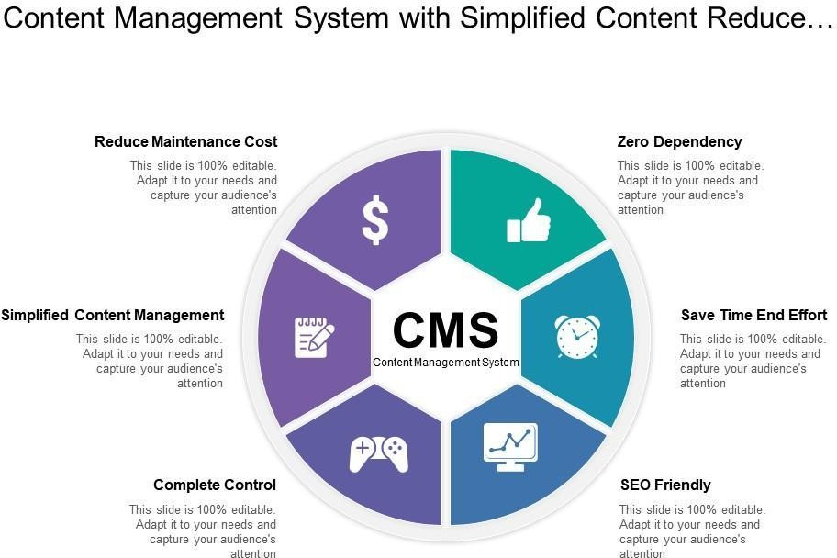

**Fig. 3.6.CMS diagram**

### 3.7 ER diagram

The ER diagram of a Content Management System (CMS) illustrates the relationships between

key entities, including users, content, categories, and permissions. It visually represents how users interact

with the system, how content is structured and categorized, and the access rights assigned to different users. The ER diagram provides a concise overview of the CMS database structure and entity relationships.

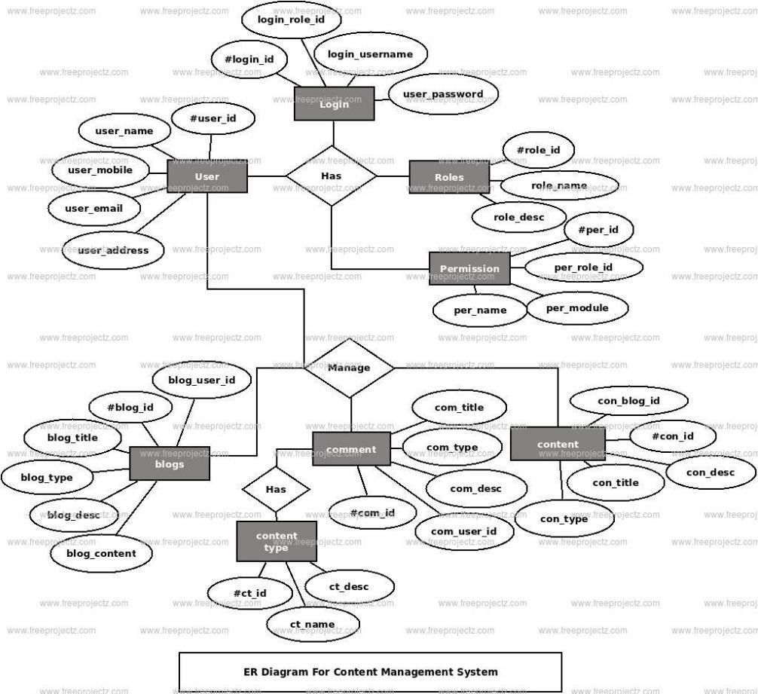

**Fig. 3.7 ER diagram**

### 3.8. Use Case diagram

The Use Case diagram for a Content Management System (CMS) visually illustrates the system's functionalities and interactions between actors and use cases. It provides a concise overview of the tasks actors can perform within the CMS and their relationships. Including the Use Case diagram in the report enhances documentation, communication, and understanding of the CMS requirements and behavior.

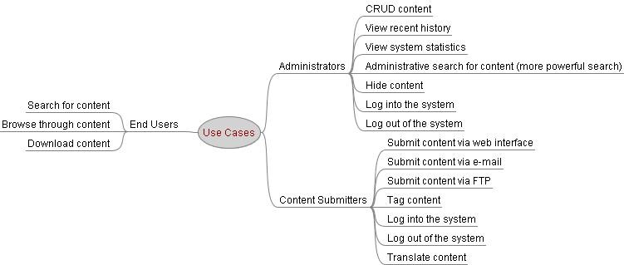

**Fig 3.8. Use Case Diagram**

# CHAPTER 4

## TECHNOLOGIES AND TOOLS UTILIZED

In this chapter, we will explore the technologies and tools utilized during the software development internship at SiliconMount Tech Services. Specifically, the focus will be on XAMPP, phpMyAdmin, Python and the Flask framework. These technologies played a crucial role in facilitating the development of firewall solutions and achieving the project objectives.

### phpMyAdmin:

phpMyAdmin is an open-source software tool , which is written in PHP. Basically, it is a third-party tool to manage the tables and data inside the database. phpMyAdmin supports various type of operations on **MariaDB** and **MySQL**. The main purpose of phpMyAdmin is to handle the administration of MySQL over the web.

It is the most popular application for MySQL database management. We can create, update, drop, alter, delete, import, and export MySQL database tables by using this software. phpMyAdmin also supports a wide range of operation like **managing databases, relations, tables, columns, indexes, permissions, and users**, etc., on MySQL and MariaDB. These operations can be performed via user interface, while we still have the ability to execute any SQL statement.

phpMyAdmin is a **GUI-based application** which is used to manage MySQL database. We can manually create database and table and execute the query on them. It provides a web-based interface and can run on any server. Since it is web-based, so we can access it from any compute

### Python:

Python is a popular programming language known for its simplicity, readability, and extensive library support. It was extensively used during the internship for developing chatbot. Python's rich ecosystem of libraries, such as pandas for data manipulation, matplotlib for data visualization, and scikit-learn for machine learning, facilitated efficient development and implementation of advanced features.

Additionally, Python's versatility allowed for seamless integration with other technologies,enabling the creation of robust and scalable chatbot functionalities.

### Flask Framework:

The Flask framework, built on top of Python, is a lightweight and flexible web development framework. Flask was employed to build the web-based interfaces and APIs for the firewall management system. Its simplicity and modular design allowed for rapid development and easy customization of the user interfaces. Flask's extensive documentation and vibrant community support proved valuable resources for problem-solving and implementing best practices in web development. Leveraging the Flask framework,

we created intuitive and user-friendly interfaces for managing chatbot configurations, monitoring network traffic, and analyzing security logs.



**Fig. 4.1 Flask Web Framework**

### Hyper Text Markup Language (HTML)

HTML, which stands for HyperText Markup Language, is a fundamental component of web development and is commonly used in internship projects. HTML serves as the building blocks for creating the structure and content of web pages. It provides a set of tags that define the elements and layout of a webpage.

During an internship project, HTML is utilized in various ways:

* + 1. Structure and Semantics:

HTML tags are used to structure the content of a webpage. These tags include headings, paragraphs, lists, tables, and more. By using semantic HTML, developers can convey the meaning and purpose of different sections, which improves accessibility and search engine optimization.

* + 1. Hyperlinks:

HTML enables the creation of hyperlinks, allowing users to navigate between web pages and resources. The anchor tag (<a>) is used to define links and specify the target URL.

* + 1. Forms:

HTML forms play a crucial role in gathering user input. Form elements, such as text fields, checkboxes, radio buttons, and dropdown menus, are used to collect and submit user data. The form data is typically sent to a server for processing.

### Cascade Style Sheet (CSS)

CSS, which stands for Cascading Style Sheets, is a vital technology in web development that is often used in conjunction with HTML. CSS allows developers to control the presentation and visual styling of webpages, including layout, colors, fonts, and more. By separating the content and structure of a webpage (handled by HTML) from its visual design (handled by CSS), developers can create visually appealing and consistent websites with ease. It offers a wide range of capabilities, including responsive design for different screen sizes, animation and transition effects, and the ability to create complex layouts. CSS is an essential tool in the web development toolkit, enabling interns to enhance the aesthetics and user experience of their internship projects.

### JavaScript (JS)

JavaScript, often abbreviated as JS, is a powerful scripting language that is primarily used in web development. It adds interactivity and dynamic functionality to websites, making them more engaging and user-friendly. JavaScript allows developers to manipulate and modify the content of webpages,

respond to user actions, and communicate with servers to fetch and update data without requiring a page refresh. With JavaScript, interns can create interactive forms, validate user input, implement image sliders and carousels, create pop-up windows, handle events like mouse clicks and keyboard input, and much more. JavaScript is a versatile and widely supported language that plays a crucial role in creating modern, interactive web

applications. By harnessing the power of JavaScript, interns can enhance the functionality and user experience of their internship projects.

### MYSQL

MySQL is currently the most popular database management system software used for managing the relational database. It is open-source database software, which is supported by Oracle Company. It is fast, scalable, and easy to use database management system in comparison with Microsoft SQL Server and Oracle Database. It is commonly used in conjunction with php scripts for creating powerful and dynamic server-side or web-based enterprise applications. MySQL is an open-source database, so you don't have to pay a single penny to use it.It is a very powerful program that can handle a large set of functionality of the most expensive and powerful database packages.MySQL is customizable because it is an open-source database, and the open-source GPL license facilitates programmers to modify the SQL software according to their own specific environment.

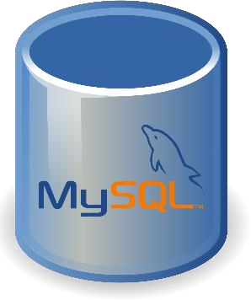

## XAMPP

**Fig. 4.2 MYSQL Database**

XAMPP is one of the widely used cross-platform web servers, which helps developers to create and test their programs on a local webserver. It was developed by the Apache Friends, and its native source code can be revised or modified by the audience. It consists of Apache HTTP Server, MariaDB, and interpreter for the different programming languages like PHP and Perl. XAMPP is an abbreviation where X stands for Cross-Platform, A stands for Apache, M stands for MYSQL, and the Ps stand for PHP and Perl, respectively. It is an open-source package of web solutions that includes Apache distribution for many servers and command-line executables along with modules such as Apache server, MariaDB, PHP, and Perl.

XAMPP helps a local host or server to test its website and clients via computers and laptops before releasing it to the main server. It is a platform that furnishes a suitable environment to test and verify the working of projects based on Apache, Perl, MySQL database, and PHP through the system of the host itself. Among these technologies, [Perl](https://www.javatpoint.com/perl-tutorial) is a programming language used for web development, [PHP](https://www.javatpoint.com/php-tutorial) is a backend scripting language, and MariaDB is the most vividly used database developed by MySQL. The detailed description of these components is given below.

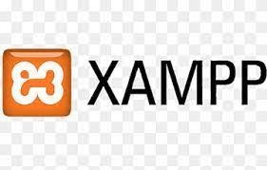

**Fig. 4.3 XAMPP**

**CHAPTER 5**

# Project

### working of database in content management system

The web content management system works in the following way:

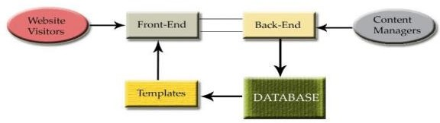

**Fig. 5.1. working of database in content management system**

### MySQL Database

In my website, I utilized a MySQL database managed through phpMyAdmin. The database consists of multiple tables, each serving a specific purpose within the website. The tables are structured with columns that define the data types, lengths, and constraints for storing information. Additionally, primary keys are assigned to ensure unique identification of records. If applicable, I implemented relationships between tables, specifying the type of relationship and the associated tables and columns. The database showcases the utilization of advanced features such as stored procedures, triggers, or views. Overall, MySQL, along with phpMyAdmin, provides a reliable and efficient solution for managing the structured data required for my website's functionality.

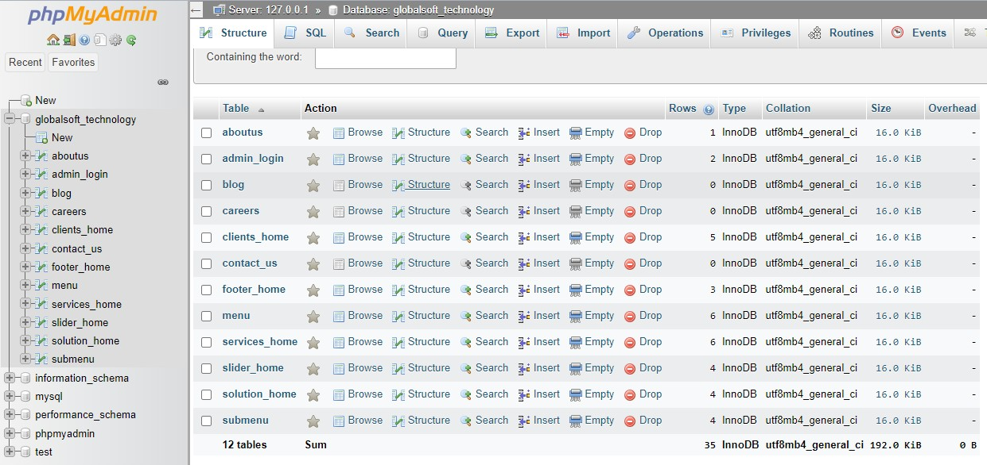**Fig.5.2.Mysql Database of website**

A Content Management System (CMS) consists of two main parts: the user/client side and the server side, with a connected database.

The user/client side: focuses on presenting content and facilitating user interaction.

Server side:- processes requests, retrieves data from the database, and generates dynamic web pages. The CMS utilizes a programming language to fetch and format information stored in the database, providing a seamless experience for website viewers. The database serves as a structured storage system for content and other data, with different database options available. The relationship between the client, server, and database is crucial for the efficient functioning of a web CMS.

# CHAPTER 6

### RESULT AND OUTCOME

During my internship at SiliconMount Tech Services, I developed a CMS-based website with various web pages such as Home, About Us, Solutions, Services, Customers, Blog, and Contact Us.

The website's Blog section allows users to add new blog entries through a submission form, which stores the information in a database. Similarly, the Contact Us form captures user details and sends an email to the admin, who then contacts the user.

Additionally, the Careers section features a form to collect information for open positions, which is also stored in the database.

To manage these functionalities, an Admin Dashboard was created. Accessible through a secure login system, the dashboard enables the admin to perform operations like adding, deleting, and updating data.

Overall, my internship involved building a dynamic website with a CMS, including a blog with submission capabilities, a contact form with email notifications, and a careers section with data storage. These features were managed through an Admin Dashboard accessed via a secure login.

### Some Snapshots

#### User Interface

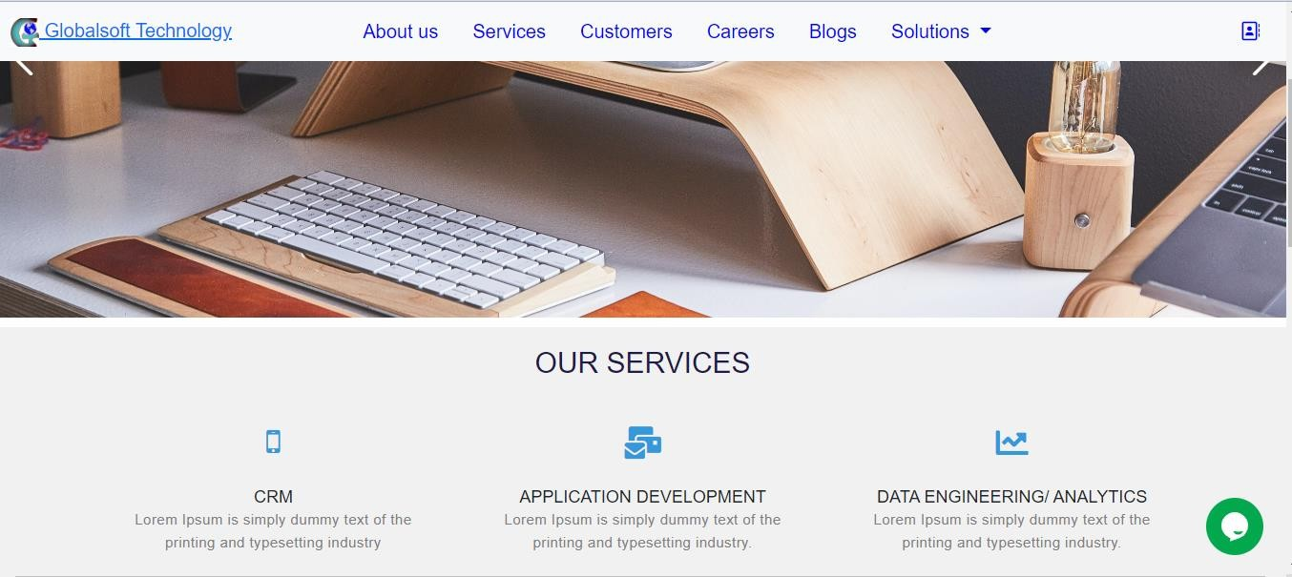**Fig. 6.1.1 User Interface**

The user interface of our website incorporates several key elements that enhance user experience and facilitate easy navigation. The menu and submenu structure provides a clear and intuitive way for users to explore different sections of the website. The sliders feature visually appealing images and content, effectively showcasing featured products, services, or promotions. The solutions section offers concise and informative descriptions of the solutions provided by my website. The footer provides important links and additional navigation options, ensuring easy access to essential pages such as the privacy policy, terms of service, and sitemap. The contact and career forms offer convenient ways for users to get in touch or submit job applications, streamlining the communication process. Overall, the user interface design focuses on simplicity, functionality, and visual appeal, creating a seamless and engaging browsing experience for visitors.

#### LIVE CHAT

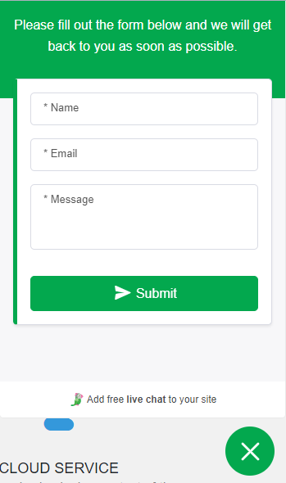

**Fig.6.1.2 LIVE CHAT**

Live chat is a website feature that enables real-time communication between users and customer support. It provides instant assistance, enhances engagement, and allows for personalized interactions, improving the overall user experience

#### CONTACT US FORM

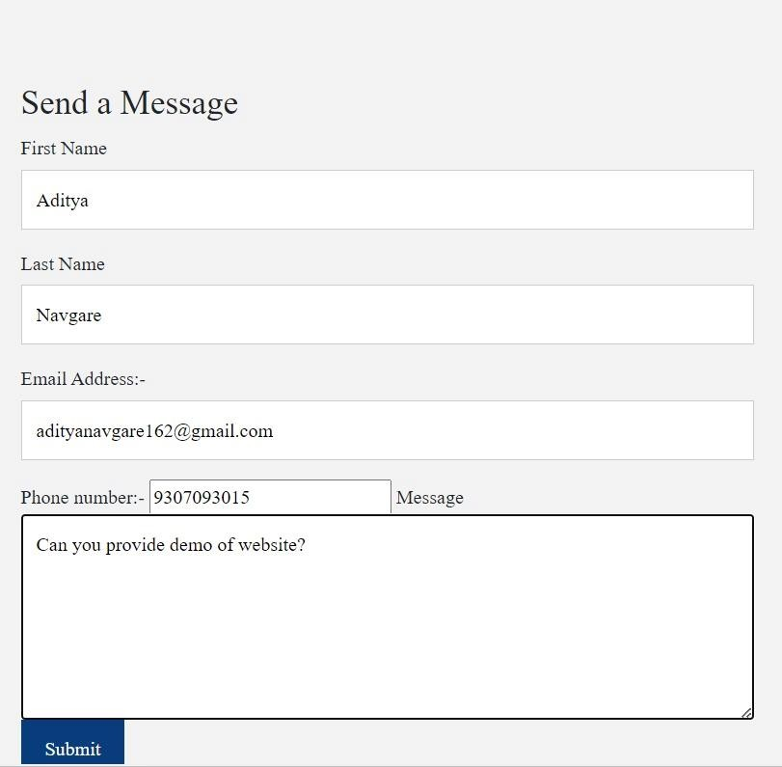

* + 1. **CONTACT US FORM**

Above is the contact us form which is embedded in the website and when the user/student/client fills the form then they get the confirmation of the submission of form as below.We used SMTP for this.

#### CONFIRMATION MESSAGE

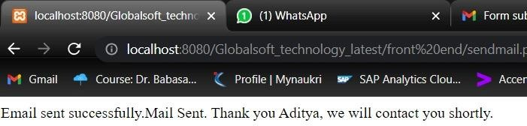

**Fig.6.1.4 CONFIRMATION MESSAGE**

And the admin also gets email if anyone submitted the form successfully.The email is sent with content/query/written by the user. It is shown as follows

#### MAIL SUBMISSION

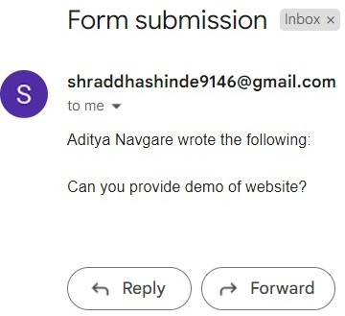

**Fig.6.1.5 MAIL SUBMISSION**

#### LOGIN PANEL

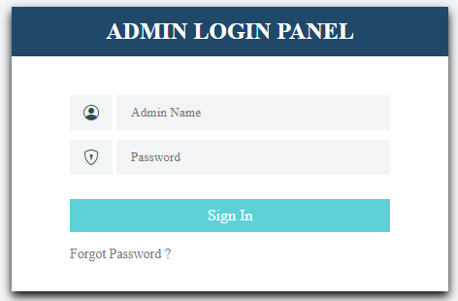

**Fig.6.1.6 LOGIN PANEL**

The admin login form allows authorized access to the website's administrative features. The username and password provided are fetched from the database to verify credentials, ensuring secure access to the admin dashboard and maintaining control over website settings.

#### ADMIN DASHBOARD

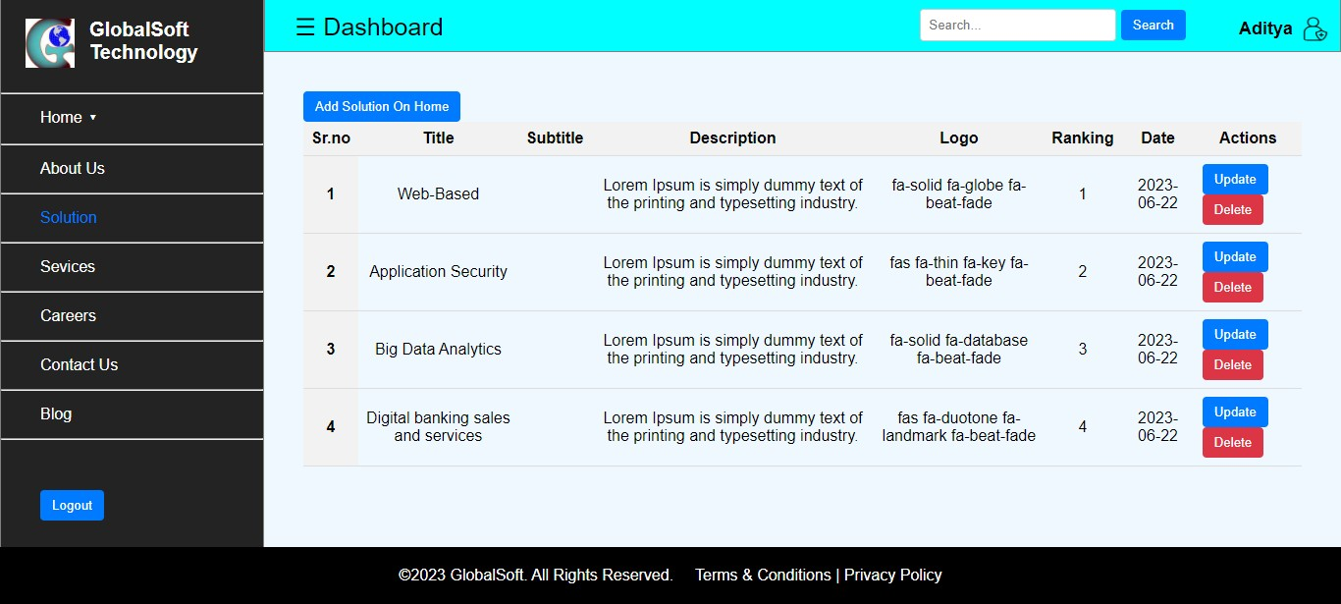**Fig.6.1.7 ADMIN DASHBOARD**

After a successful login, the admin is directed to the admin dashboard, a customized interface designed for managing and editing website content. The dashboard provides various accessible forms and tools that allow the admin to make content modifications effortlessly. Through these forms, the admin can update text, images, and other elements across different sections of the website. The intuitive interface simplifies the editing process, enabling the admin to quickly make changes without extensive technical knowledge. With the admin dashboard, the website's content can be easily maintained and kept up-to- date, ensuring a seamless user experience for visitors.

**CONCLUSION**

Content management systems are relatively new in the market, and while many are still not familiar with them , they have the potential to dramatically simplify the maintenance of both websites and intranets. Identifying key business goals should be the starting point for every CMS project. With these in hand, a system can be selected that the outcomes are measurable, and the business strategies will be met.

As mentioned earlier, there are many ready-made solutions. There are both open source and proprietary groupware systems. Some of them are being developed for many years, supported by a broad technical background, and also recognized among the Internet community. There are many modules that can be used when creating web pages. It is difficult to catch up so the developed systems. But it was not the objective of this project. It let me learn about such systems and learn the rules of their functioning. Of course, the question arises whether to use ready-made systems, or write your own. Both approaches have their advantages and disadvantages. On the one hand, ready to use systems reduces the time to prepare the websites, through the use of ready-made modules. Troubleshooting is made easier because of the technical support and online community. Writing your own application is time consuming, but allows for full flexibility in decision making. We can make decisions as the content stored in the system will be presented on the Web and how content will be handled as dynamic. Preparing your own content management system obviously requires a lot of work-related the development of appropriate safeguards, can implement the required functionality and maintenance of the system. But gives a possibility of full freedom in changing and upgrading components.

### BIBLIOGRAPHY

* + - 1. Robertson, J. (2002), ‘How to evaluate a content management system’, KM Column.
      2. Robertson, J. (2004), ‘Open-source content management systems’, KM Column.
      3. Haug, A. (2012) The Implementation of Enterprise Content Management Systems in SMEs. Journal of Enterprise Information Management, 25, 349-372. <http://dx.doi.org/10.1108/17410391211245838>
      4. <http://www.cmswiki.com/tiki->
      5. index.php?page=HistoryOfCMS
      6. [http://www.cmswiki.com/tiki-index.php?page=Content](http://www.cmswiki.com/tiki-index.php?page=Content%20)
      7. <http://en.wikipedia.org/wiki/Content_management>
      8. [www.w3school.com](http://www.w3school.com/)
      9. [http://en.wikipedia.org/wiki/Relational_database_management_system.](http://en.wikipedia.org/wiki/Relational_database_management_system)